1. Introduction

1.1 About the Project

This project is essentially a web shop for selling jerseys.

(https://github.com/fadara82/jerseyshop.git)

1.2 Project Functionalities and Screenshots

The main features of this project are logging in, registration, adding, editing and deleting products, products depending on the role of the user, then we also have a basket for selected products.

Screenshots:

Login

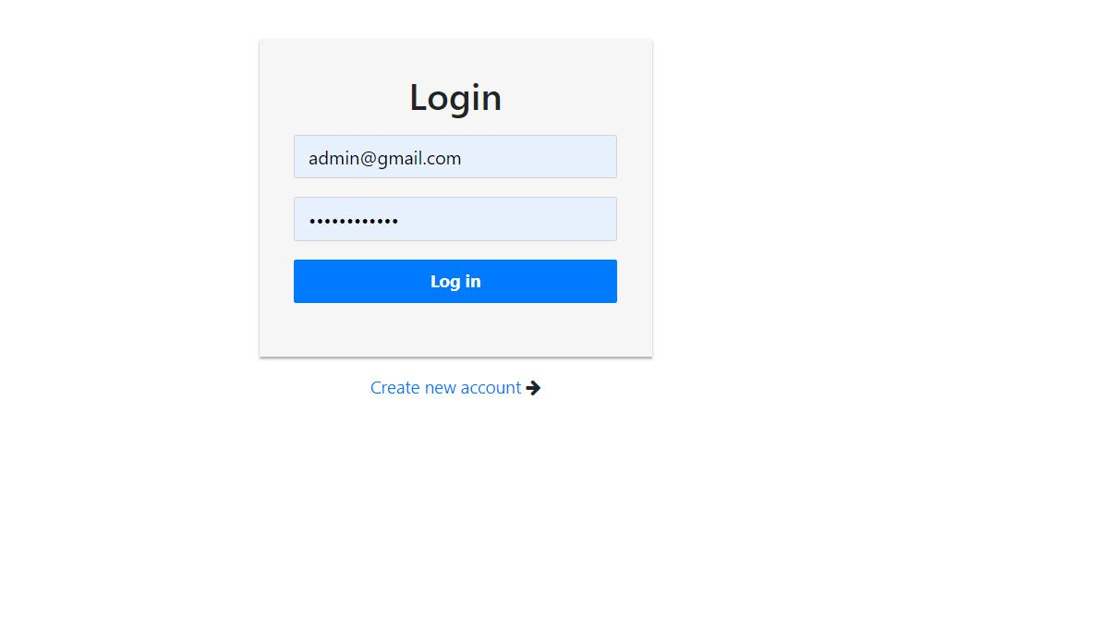

Register

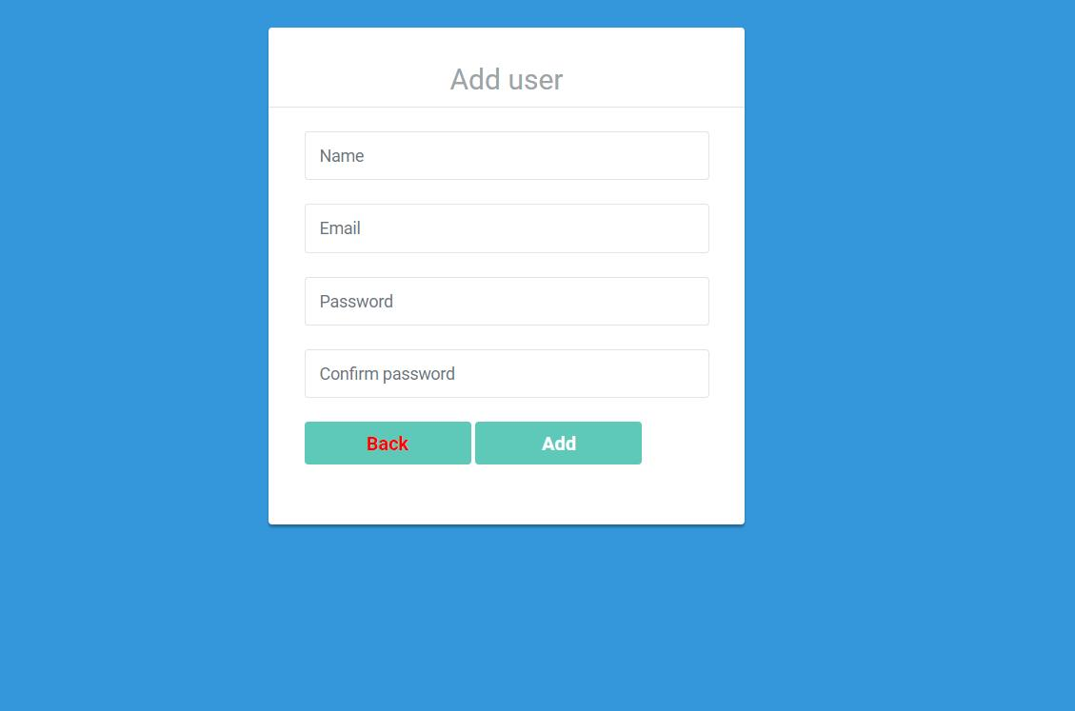

Guest



Dashboard

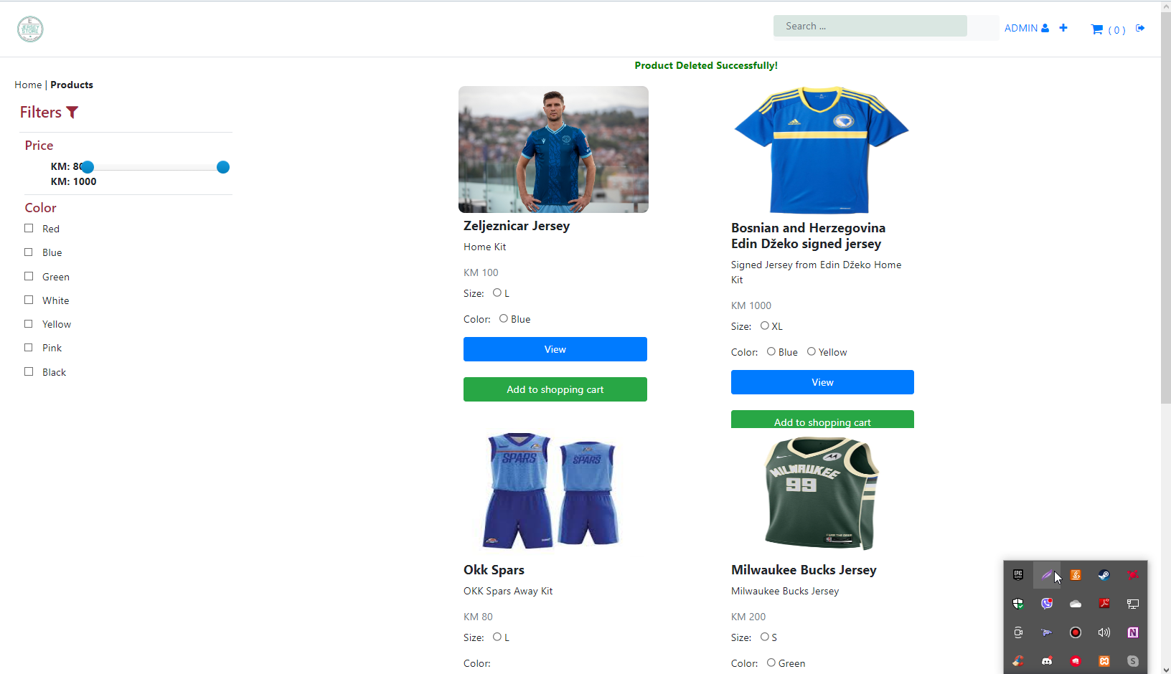

View item

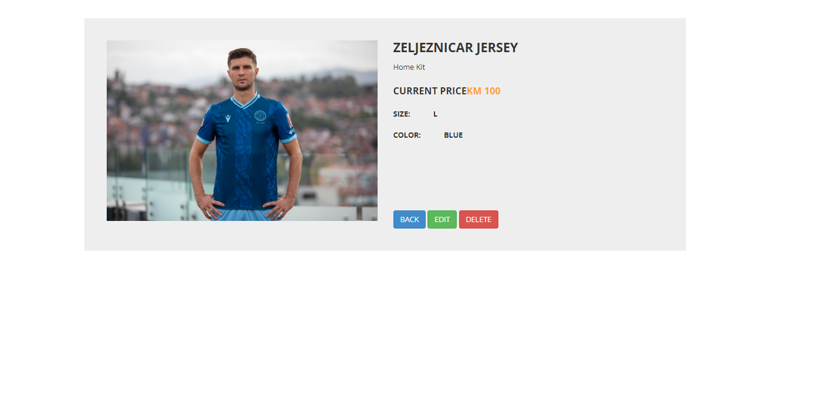

Shopping cart

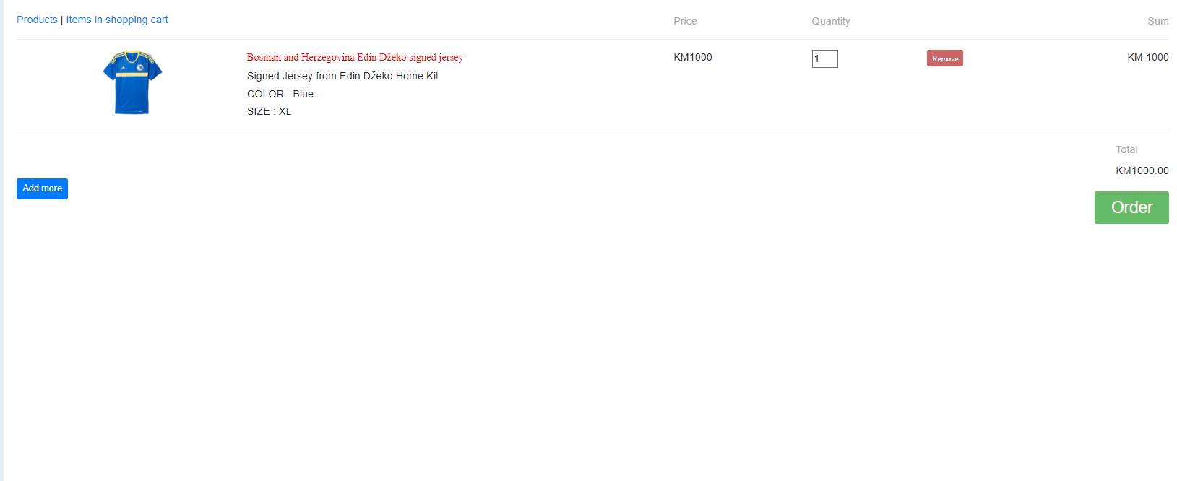

1. Project structure

2.1 Technologies

On the backend we used laravel, php framework and mysql database and the tool for mysql is in phpmyadmin which is part of the xampp installation package. On the frontend within the blade.php files javascript, jQuery, ajax and bootstrap were used for responsive design.

Laravel is php object-oriented by itself, so it has a built-in MVC model.

## 2.2. Database Entities

Inside db we have 11 tables namely articles, cart_items, color, migrations, password_resets, photos, posts, products, product_images, users, wishlist. (The name of the table roughly tells what it is for, based on the columns in each table it is clear what it is for).

## 2.3. Design Patterns

The Builder pattern is one of the main design patterns of Laravel. It separates the construction of a complex object from its representation so that the same construction process can create different representations. A builder is good for creating complex products.

All the creational patterns focus on producing products. Some products are just naturally complex, though. So in that case, you can represent the building process to a director and builder.

(

Read more on this link

<https://codesource.io/brief-overview-of-design-pattern-used-in-laravel/>

)

## 2.4. Tests

# Conclusion

In my opinion, it is good that we have different options on the website based on the role of the user. In the future, if the website were to be used as a real website on the Internet, a real way of paying for the products should be added. The most demanding part was adding the controller related to the product overview and also the shopping cart, while the part for logging in and registering was usual.